Activity 2 - Part 1
Simulate MiRo to output a sequence of sounds when the input ‘clap’ is heard.

Step 1-7  - Add ‘program start’ from ‘Setup’  - Add 1 x ‘wait for clap’ block from ‘Sensors’  - Add 2 x ‘play tone’ blocks  - Set 2nd tone to 1000 Hz  - Add 2 x ‘wait’ blocks | ** The number of seconds can be adjusted and experimenting with this is encouraged to predict the effect on the output.
Step 8  - Click Simulator Play OR  - Click Robot play | ** If you are using the physical MiRO ensure the IP address is correctly added to the onscreen code to allow the code to be communicated to MiRO to action.  ** If you are using the simulator it is recommended to zoom in to see miRo clearly but not essential
 | 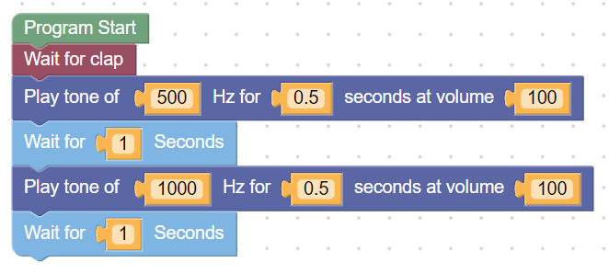
Extension: What happens if you adjust the tone, the seconds or the volume within the blocks?
Hear the output | 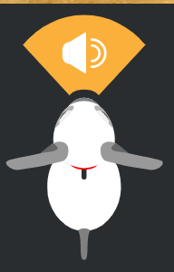

Following how the program executes will help the pupils identify when an error occurs.
A program | 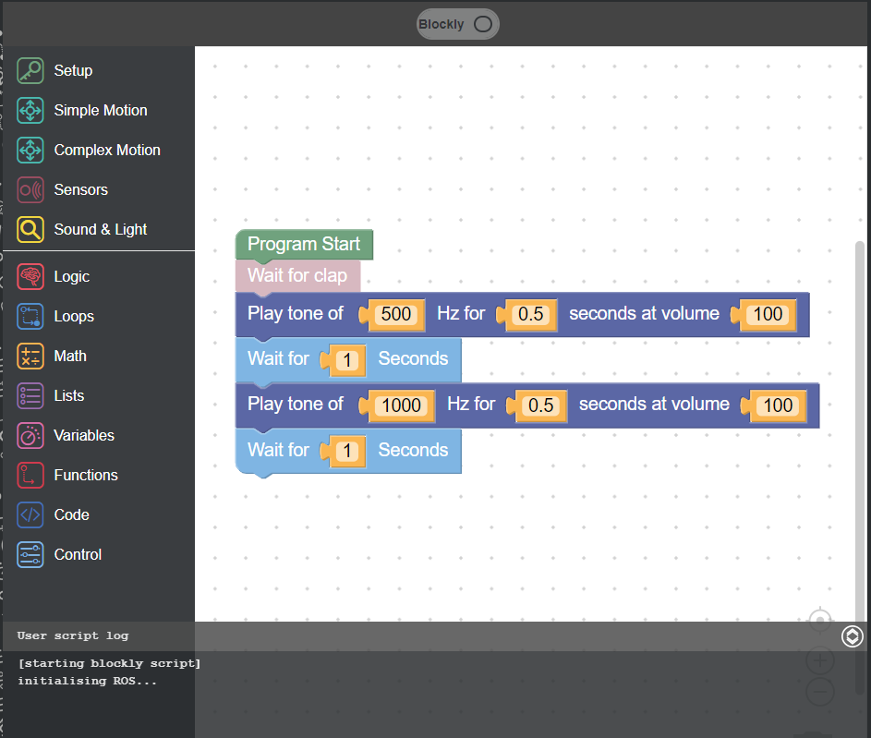  Script at bottom of screen shows code is ready and waiting for the ‘clap’ | 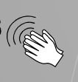  Simulate the clap by clicking this icon  OR  With physical MiRo - clap your hands | 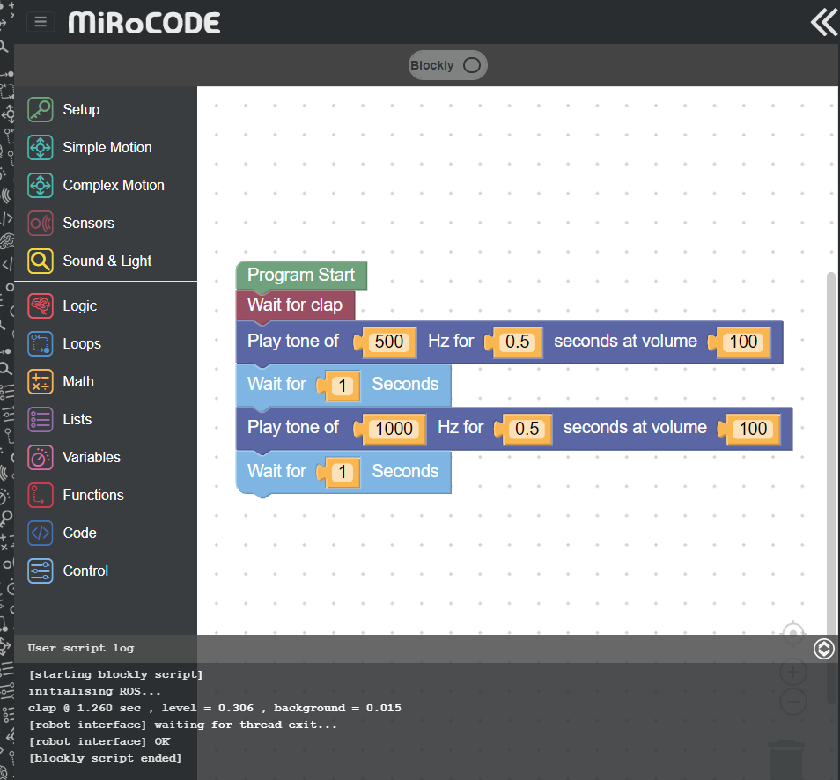  Script at bottom shows program ran correctly.Follow

Activity 2 - Part 2
Simulate MiRo to output a sequence of sounds and light when the input ‘clap’ is heard.
**This program builds on the previous activities program so pupils need to keep their program on their screen to build on.**

Teachers version:
Step 1 - Zoom in to see MiRo’ face if using the simulator | ** maybe a note that this is optional for higher ability pupils as this may be tricky for younger users???
Step 1-6  - Add ‘program start’ from ‘Setup’  - Add 2 x ‘change front LED’ blocks from ‘Sound and Light’  - Set the both from ‘front’ to ‘all’  - Set second colour to ‘yellow’ | ** opportunities for pupil’s to observe the effects on the output by adjusting the sound and colour blocks.  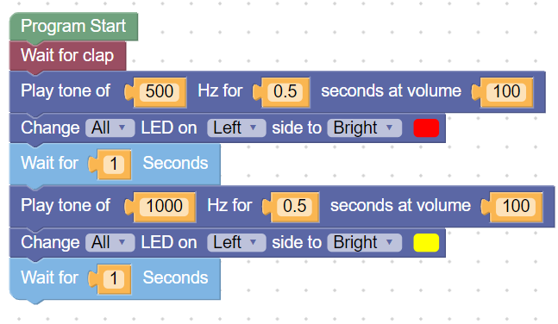
Step 7  - Click Simulator Play OR  - Click Robot play | ** If you are using the physical MiRO ensure the IP address is correctly added to the onscreen code to allow the code to be communicated to MiRO to action.  ** If you are using the simulator it is recommended to zoom in to see miRo clearly but not essential

See and Hear the output |  |  | 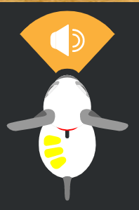

Extension  Click the button above the block code with the word ‘Blockly’ on it and switch the screen to ‘python’. Can you narrate anything that happens in the code?  For higher ability pupils ask them to adjust the settings within the line of code with the same set of numbers as the block. |  | 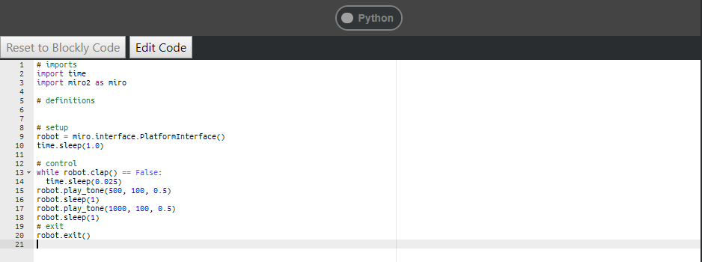

Step-by-Step
Simulate MiRo to move forward, turn and move towards and knock down the cans.

Step | Image
1 – Set Up  - Blocks from ‘Setup’ icon and is the start of all programs. | 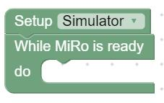
2 – Add Repeat Loop  - Block from ‘Loops’ icon. | 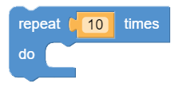
3 – Add Movement  - Block from ‘Simple Motion’ icon and set to ‘fastest’ from the dropdown menu available. | 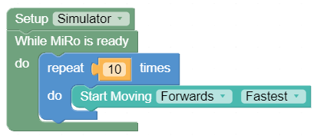
4 – Add Send Commands  - Block from ‘Setup’ icon. | 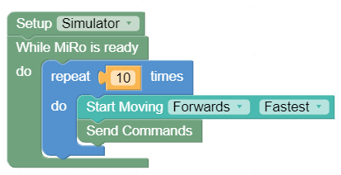
5 – Add Wait block  - Block from ‘Control’ icon. | 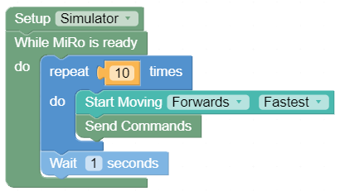
6 – Add Repeat Loop  - Block from ‘Loops’ icon.  OR  - Right click and duplicate the other ‘repeat 10 times’ block. | 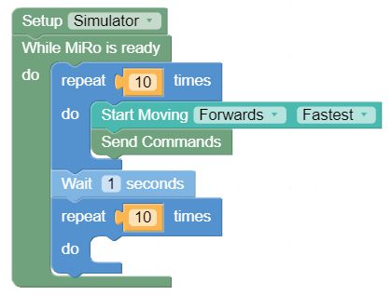
7 – Add Turning Movement and Send Commands blocks  - Block from ‘Simple Motion’ icon, add set to ‘left’ and ‘fastest’ from the dropdown menus available.  - Block from ‘Setup’ icon. | 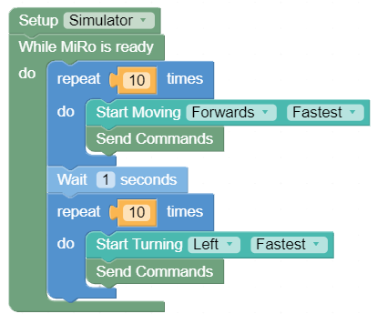
8 – Add Wait block  - Block from ‘Control’ icon. | 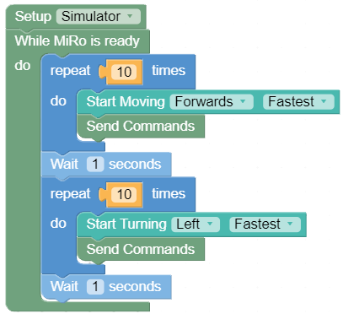
10 – Add a third Repeat block with Forward movement  - Block from ‘Simple Motion’ icon and set to ‘fastest’ from the dropdown menu available.  - Block from ‘Setup’ icon. | 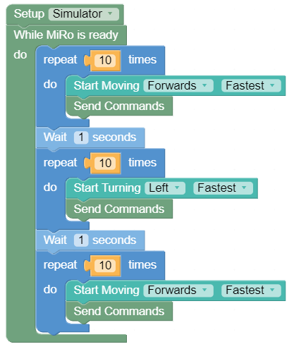
10 – Simulate  Click ‘Simulate and you will see MiRo start to move forward for 10 steps, turn for 10 steps and move forward for 10 steps.  Click Cancel to stop the simulation.  If MiRo gets stuck or you wish to start the simulation again you can reset the world. | 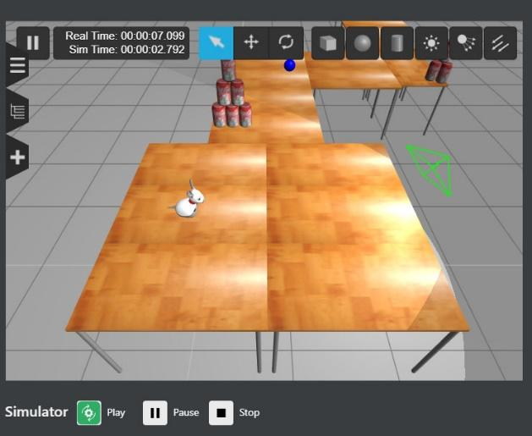
11 – Experiment with the number of times the repeat loops run for

The learners are encouraged to change the numbers on the repeat loops and simulate and test the outputs to find the correct settings to get MiRo to hit the stacked cans.

Activity 2 Program solution
NB. There can be more than one solution in programming, encourage experimentation and use solution below as a guide
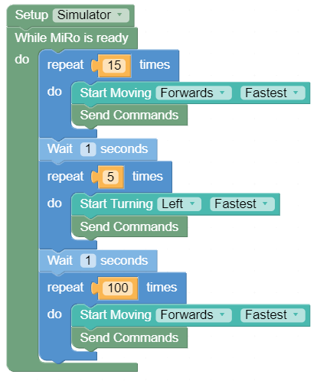
The final numbers will differ depending on the computer being used and these are only an indication

