Step-by-Step
Activity 2 Part 1

Create a block based program to utilise the sensors to stop MiRo falling off the table:
Step 1 -  - Add ‘program start’ from ‘Setup’ | 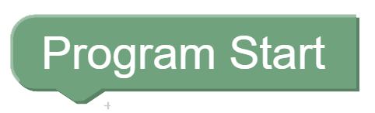
Step 2 -  - Add ‘wait for clap’ from ‘Control’  - Connect to ‘Program Start’ | 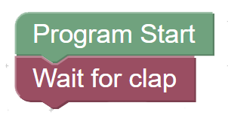
Step 3  - Add ‘Periodic Control do’ block from ‘Setup’.  - Connect to ‘wait for clap’ | 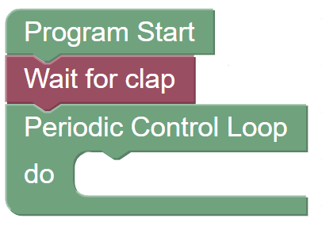
Step 4  - Add ‘if do’ block from ‘Logic’.  - Add ‘( ) and ( )’ block from ‘Logic’..  - Connect together inside the ‘periodic control loop’ block.  - Change ‘and’ to ‘or’ in the dropdown menu. | 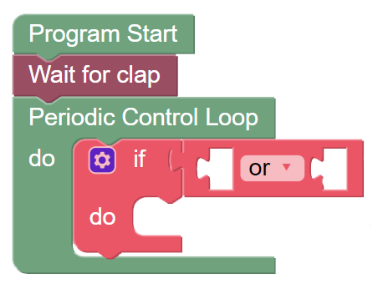
Step 5  - Add 2 ‘Left Cliff Sensor’ blocks from ‘Sensor’  - Add one to either side of the ‘or’ section.  - Change one to ‘right’ | 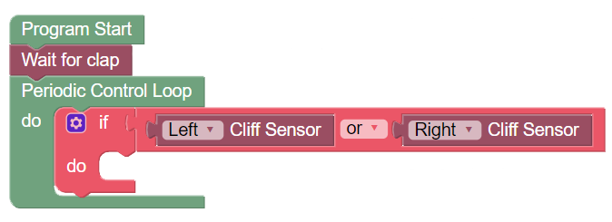
Step 6  - Add ‘start Moving forwards slow’ from ‘Simple Motion’  - Connect into the ‘do’ section  - Change to ‘Backwards’ and ‘Fastest’ | 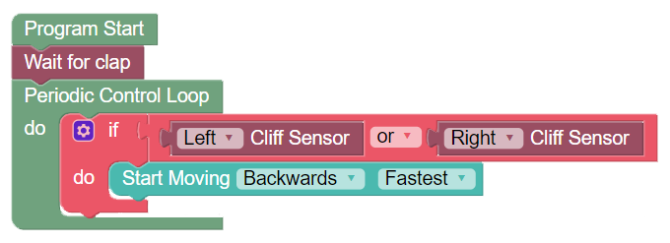
Step 7  - Add ‘wait for 1 seconds’ block from ‘Control’  - Connect under the ‘start moving backwards’ block. | 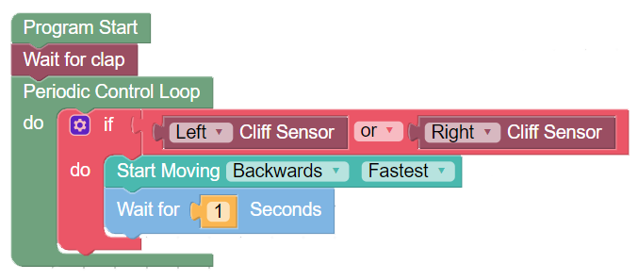  MiRo will now move forwards until the ‘left’ or the ‘right’ cliff sensor is activated, then MiRo will go backwards.
Step 8  Click  Robot Play  OR  Simulator Play | 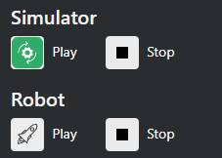
Remember  You need to clap to start MiRo moving - if on the simulator click the ‘clap’ icon to simulate a clap. | 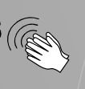
Debug
Why isn’t MiRo moving?
Can you see what is missing and find and fix the error?

Activity 2 Part 2

Step 1 -  - Flip to Python code by clicking on the ‘Blockly’ button. | 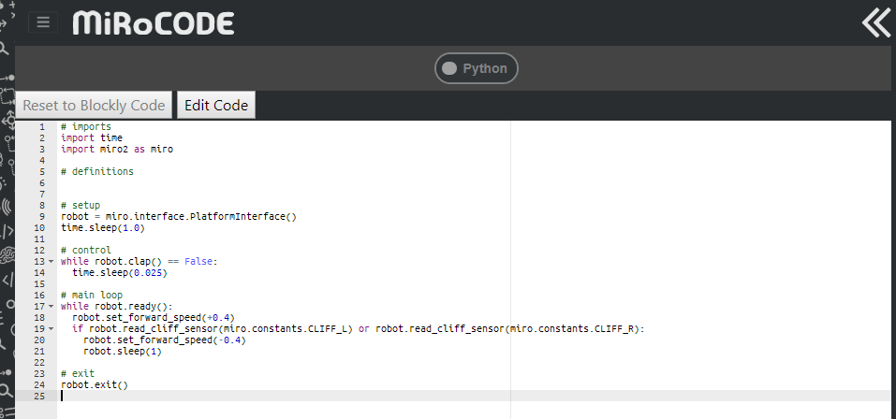
Step 2 -  - Select and copy the line of code for moving forward | robot.set_forward_speed(+0.4)
Step 3  - Flip back to ‘Blockly’ view and add a ‘run code’ block in after the ‘move forward’ block. | 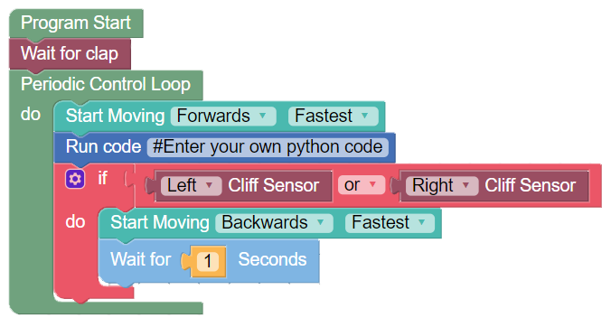
Step 4  - Paste the code into the ‘run code’ block.  - Delete the ‘’move forwards’ block. | 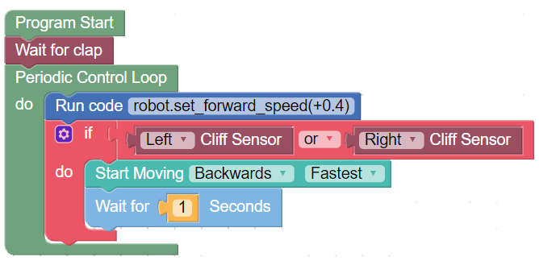
Step 5
- Run your program
- Experiment with the settings and investigate:
  - Change the speed setting from 0.4 to 0.1
  - Change the speed to minus the number added i.e. -0.4
  - Can they add the code block elsewhere and remove the blocks?
  - Can they edit the settings directly in python view?

