Step-by-Step

Activity 2 Part 1
Simulate MiRo to output a sequence of sounds when the input ‘clap’ is heard.

Step | Block | From | Connect
1  Add 1 x program start block | 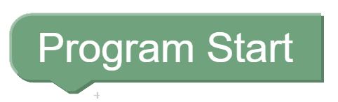 | 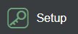
2  Add 1 x Periodic Control Loop block | 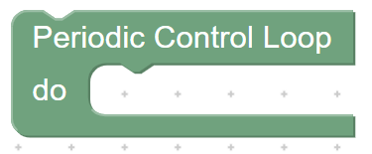 |  | 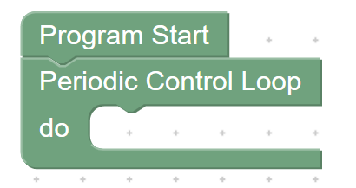
3  Add 1 x if do block | 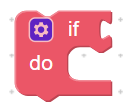 | 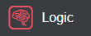 | 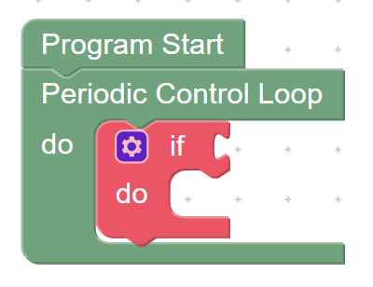
4  Add ‘else’  Click the blue settings icon  Click and drag an ‘else’ block from the left and connect under the ‘if’ on the right  Click the blue settings icon to close the pop up |  |  | 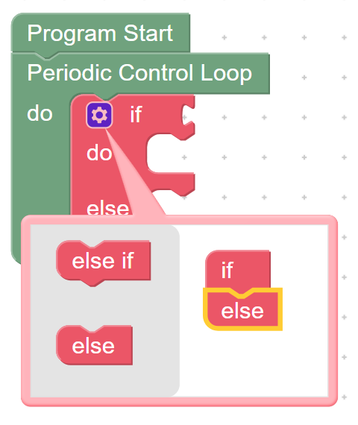
5  Add 1 x clap detected in previous 2 seconds block | 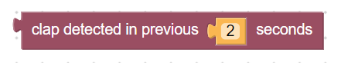 | 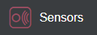 | 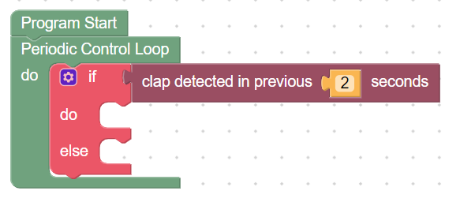
6  Change the number of seconds to 1 |  |  | 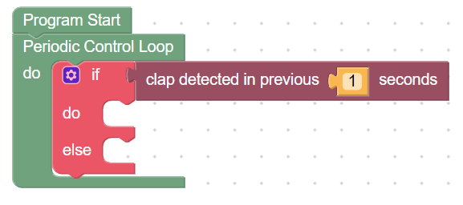
7  Add 1 x Raise/Lower Head Raise block | 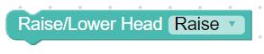 | 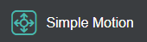 | 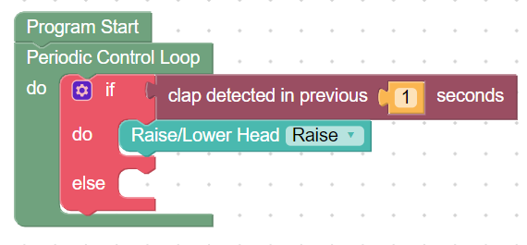
8  Add 1 x wag tail slow for 3 seconds block | 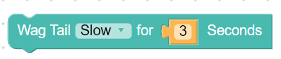 |  | 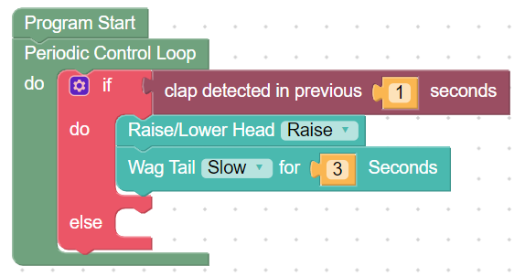
9  Set the tail to wag ‘fastest’ and for 2 seconds |  |  | 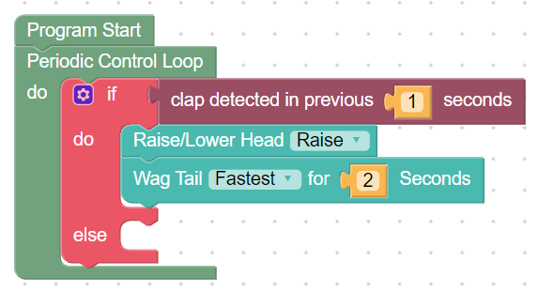
10  Add 1 x Raise/Lower Head Raise block |  |  | 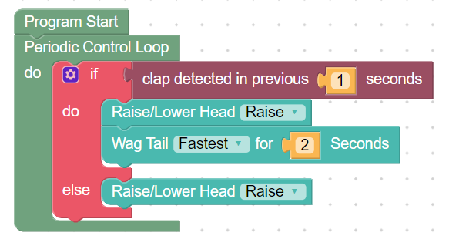
11  Click  Robot Play  OR  Simulator Play |  |  | 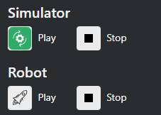
Follow a program | 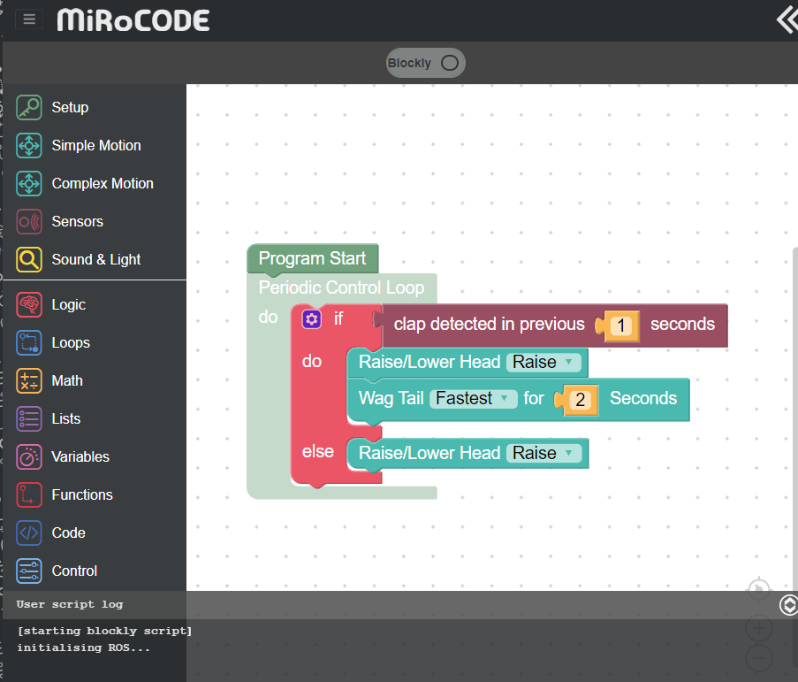  Script at bottom of screen shows code is ready and waiting for the ‘clap’ | 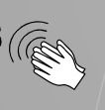  Simulate the clap by clicking this icon  OR  With physical MiRo - clap your hands | 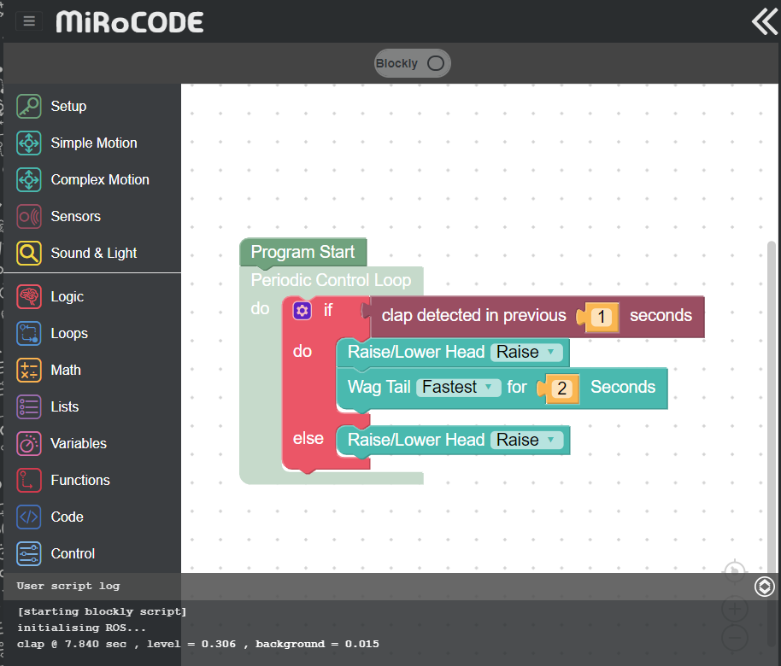  Script at bottom shows program ran correctly.
Observe the output:

Test | Expected outcome | Actual outcome | Action
Within 1 second of clap. | Head raises and tail wags
After 1 second of clap | Head lowers and tail stops

Activity 2 part 2
Within this activity the use of colour is added to the program to simulate the mood when MiRo raises and lowers its head.

Step | Block | From | Connect
1  Add 2 x change front led block | 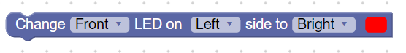 | 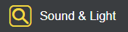 | 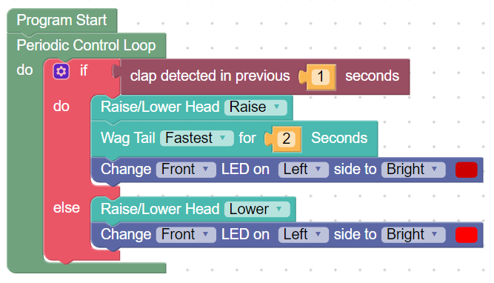
2  Set from ‘change front’ to ‘change all’ on the drop-down menu |  |  | 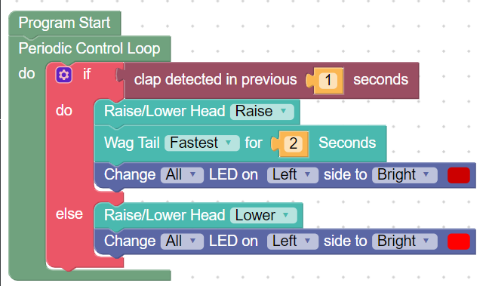
3

Click
Robot Play
OR
Simulator Play
Follow a program | 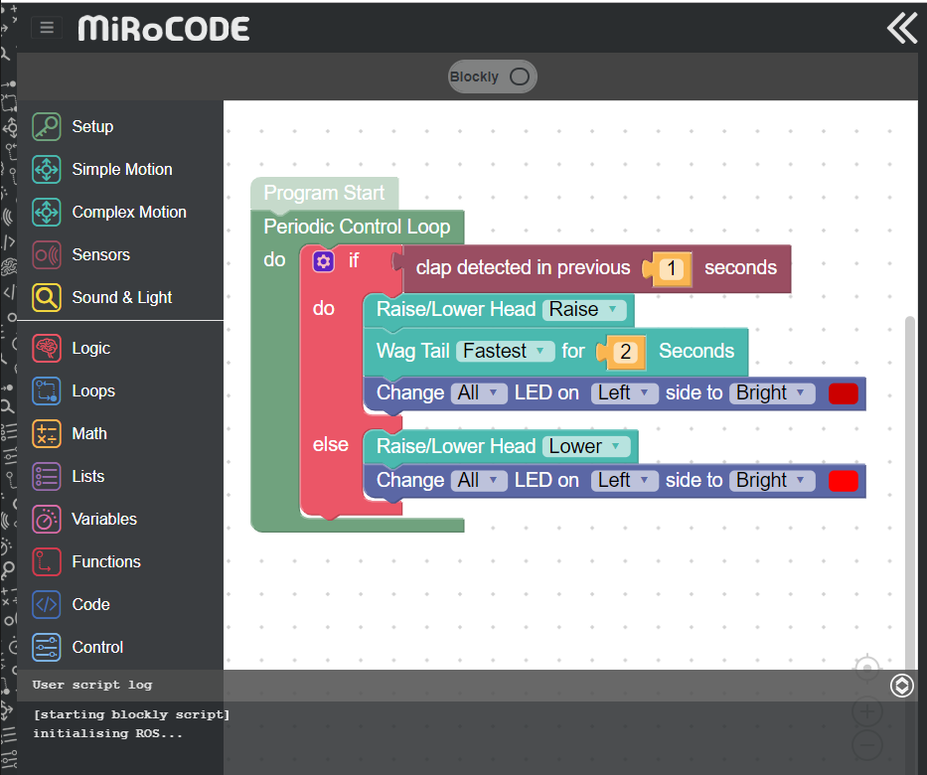  Script at bottom of screen shows code is ready and waiting for the ‘clap’ | Simulate the clap by clicking this icon  OR  With physical MiRo - clap your hands | 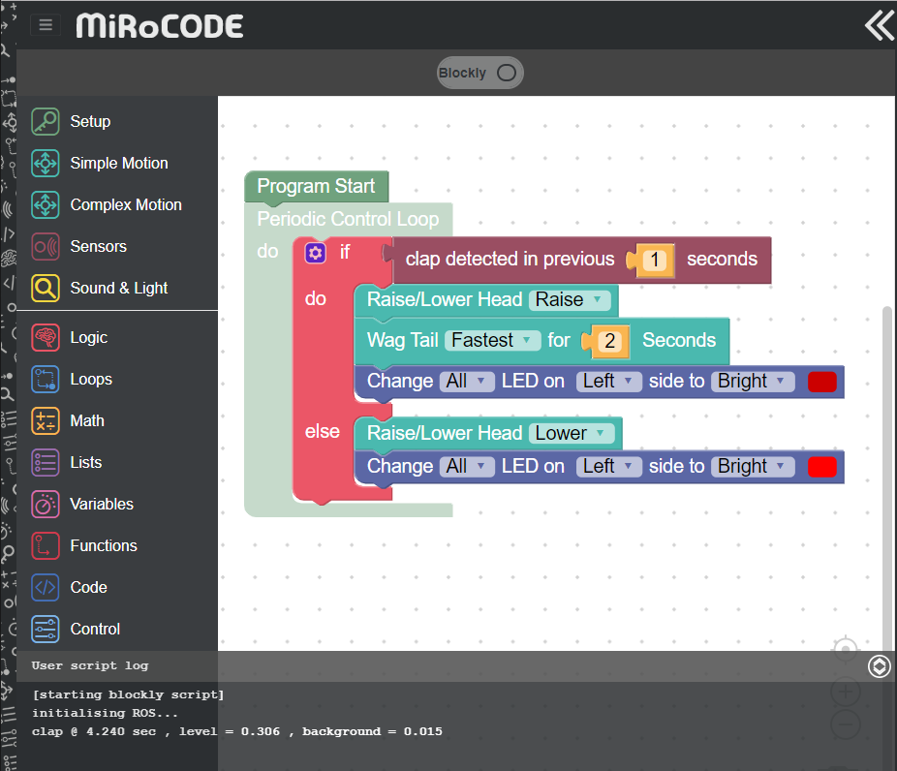  Script at bottom shows program ran correctly.
Observe the output
Test | Expected outcome | Actual outcome | Action
Within 1 second of clap. | Head raises, tail wags and lights green
After 1 second of clap | Head lowers, tail stops and lights red

Debugging  From your test table you will find that the colour red is used in both blocks.  Click the button above the block code with the word ‘Blockly’ on it and switch the screen to ‘python’. |  | 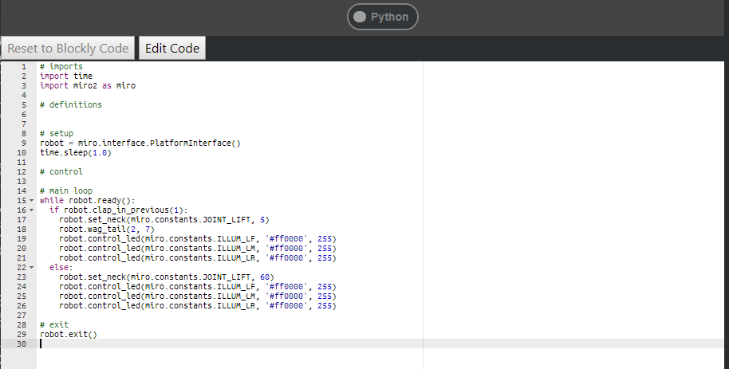
Lick the ‘Edit Code’ button.

Identify where the colour code ‘#ff0000’ is used. It is used in 6 different locations.

The first three are the ones you need to edit to a new colour.

RGB stands for Red, Green, Blue and the numbers or letters identify how much of each colour is added to make up the new colour.
Edit the colour code to:  #00ff00  Test your program - Click ‘Play’ from python view |  | 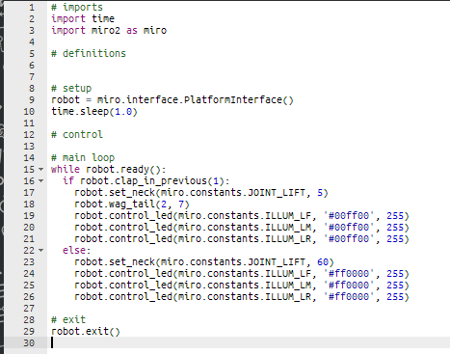
https://www.w3schools.com/colors/colors_picker.asp  Find another RGB colour code and try it out by editing the python code.  Try changing each code to a different RGB colour code. |  | 