Step-by-Step
We are going to create a program where MiRo will open its eyes, wag its tail and display green colours IF you pat MiRo’s head. If MiRo does not sense a touch, it will close its eyes and display red colours.

Step | Block | From | Connect
1  Add 1 x program start block | 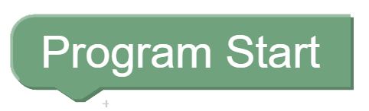 | 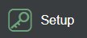
2  Add 1 x Periodic Control Loop block | 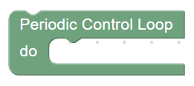 |  | 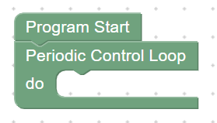
3  Add 1 x set item block | 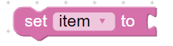 | 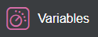 | 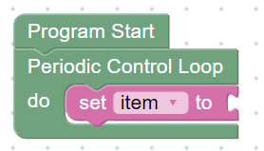
4  Rename the variable to ‘stroked’ by:  - Click the arrow next to the word ‘item’  - Select ‘rename variable’  - Rename variable to: ‘stroked’ |  |  | 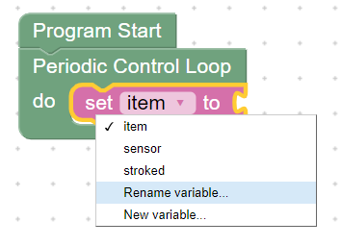
5  Add 1 x true block | 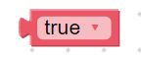 | 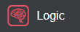 | 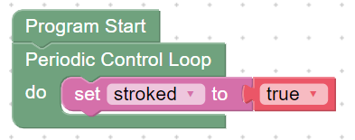
6  Change ‘true’ to ‘false’ within the drop-down menu |  |  | 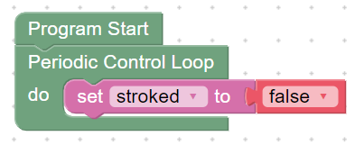
7  Add 1 x for each item ‘i’ in list block | 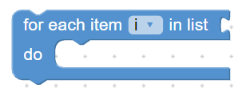 | 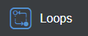 | 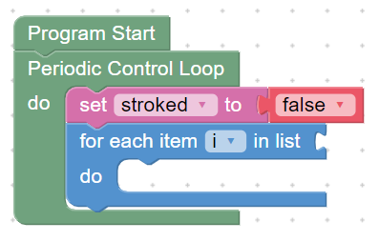
8  - Click the arrow next to the letter ‘i’  - Select ‘rename variable’  - Rename variable to: ‘sensor’ |  |  | 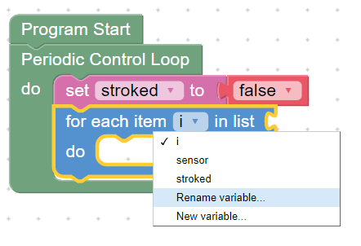
9  Add 1 x head touch sensors block | 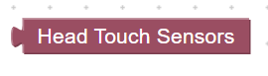 | 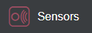 | 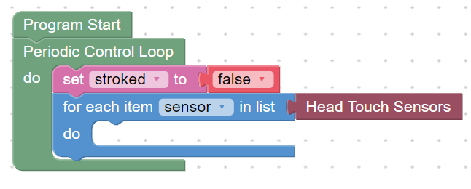
10  Add 1 x if do block | 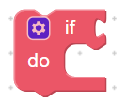 |  | 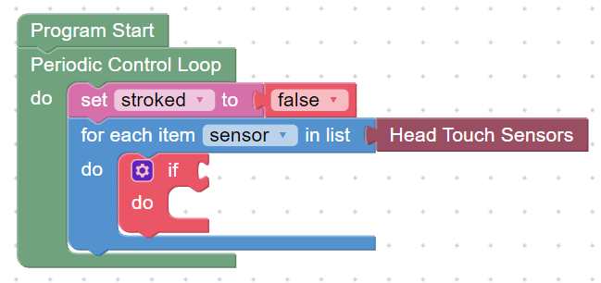
11  Add 1 x ( ) = ( ) block |  |  | 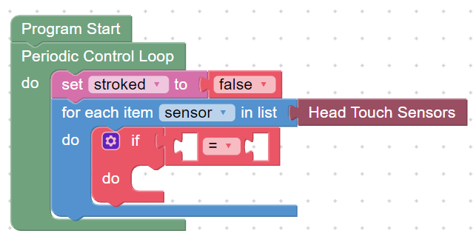
12  Add 1 x sensor block | 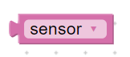 |  | 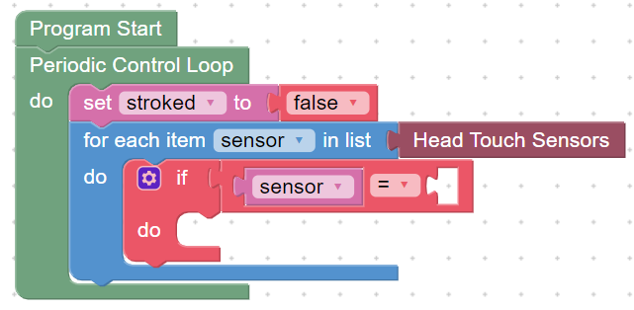
13  Add 1 x (0) block | 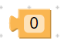 | 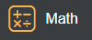 | 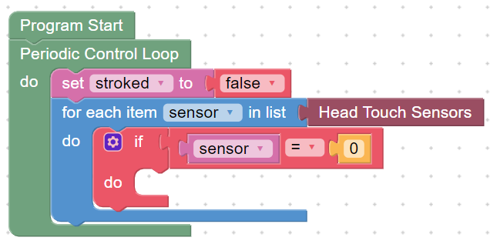
14  Set the math block to: 1 |  |  | 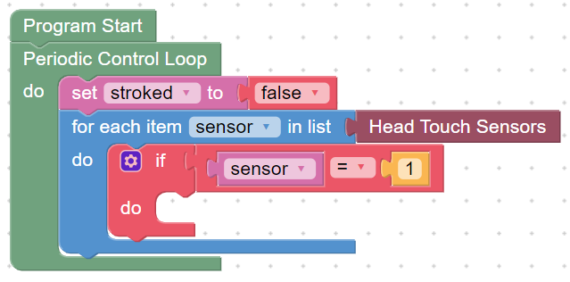
15  Add 1 x set stroked to block | 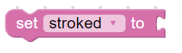 |  | 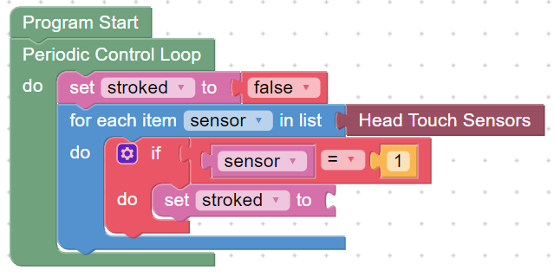
16  Add 1 x true block |  |  | 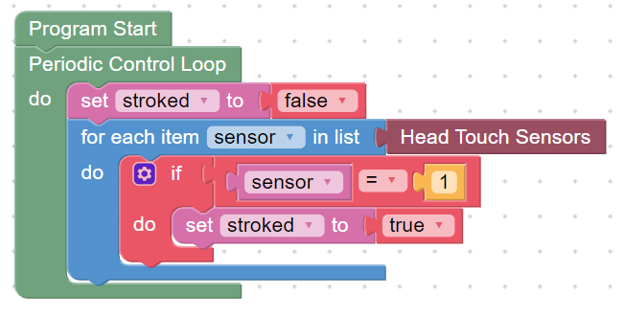
17  Add 1 x if do block |  |  | 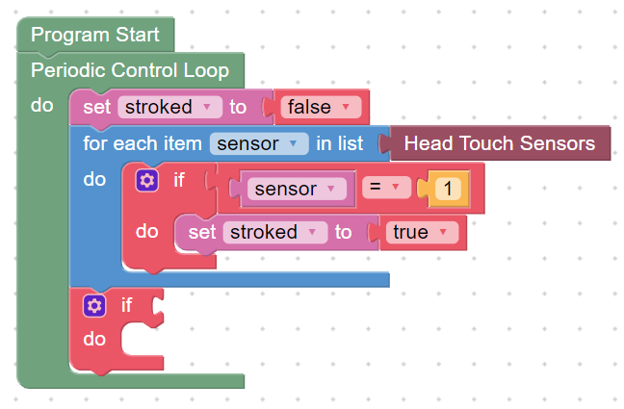
18  Add 1 x else section by clicking the blue settings icon and dragging an else over to connect under the if section. |  |  | 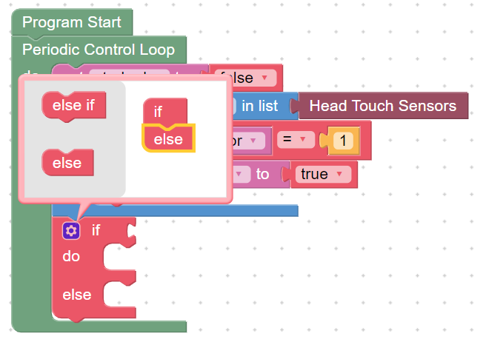
19  Add 1 x sensor block | 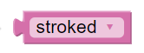 |  | 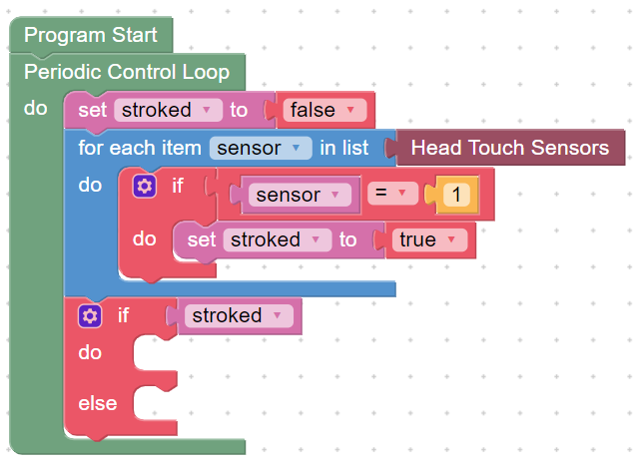
20  Add 1 x change front LED on left side to Bright red block | 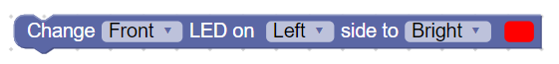 | 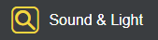 | 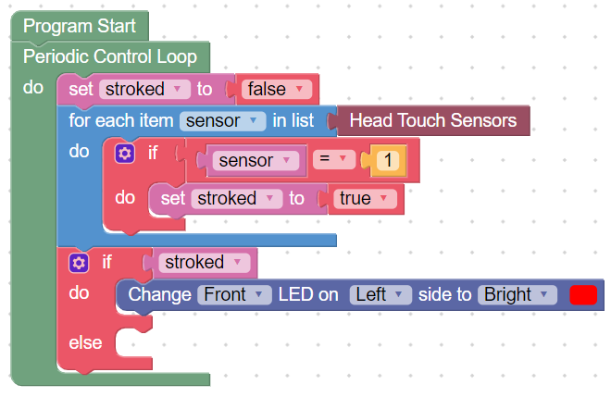
21  Set the block to ‘All’ LED on ‘Both’ side to Bright ‘green’ within the drop-down menus |  |  | 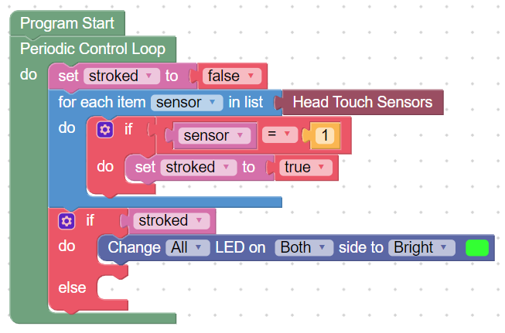
22  Right click and duplicate the ‘change All LED on Both Bright green’ block  Set colour to ‘red’ |  |  | 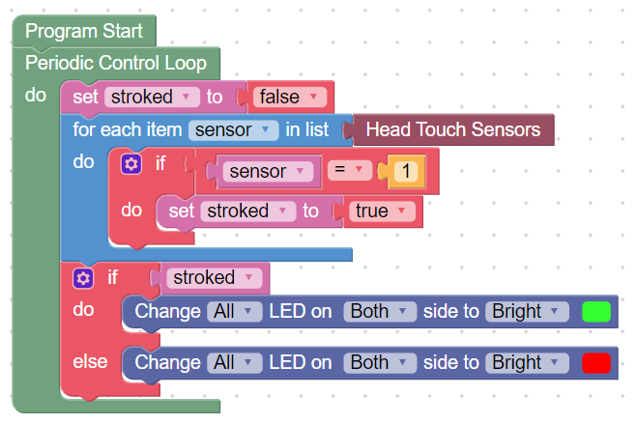
23  Add:  1 x Move Left Eyelid(s) block  1 x Wag Tail block  1 x Look Up/Down block | 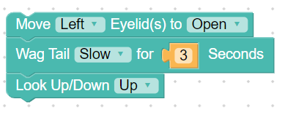 | 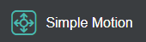 | 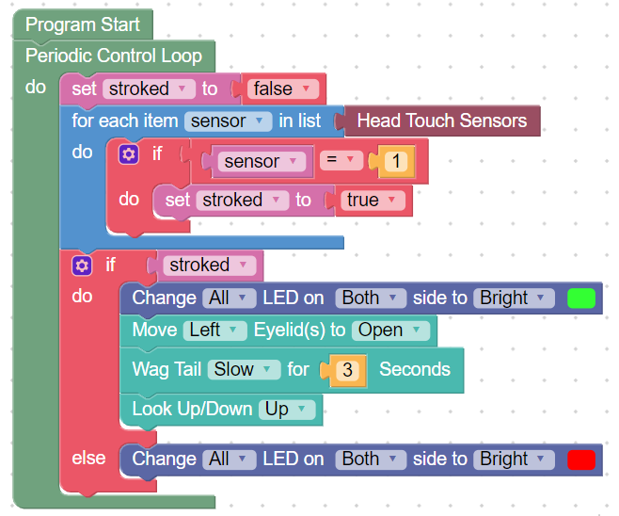
24  Set the blocks to open both eyelids and wag tail fastest for 1 second |  |  | 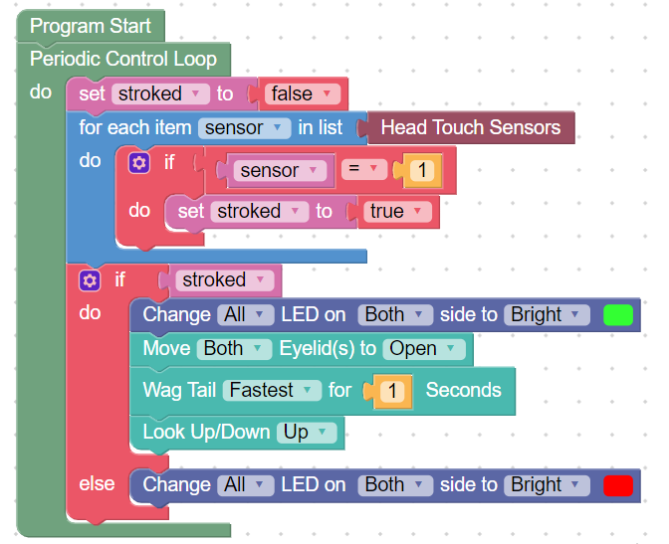
25  Right click and duplicate the ‘move both eyelids to open’ block |  |  | 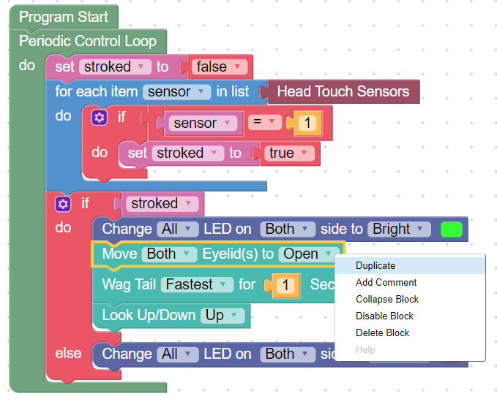
26  Set to ‘closed’ |  |  | 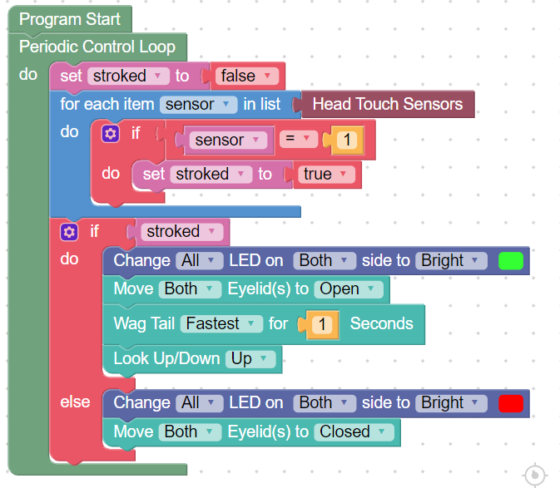
27  Click  Robot Play  OR  Simulator Play |  |  | 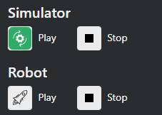
Follow a program | 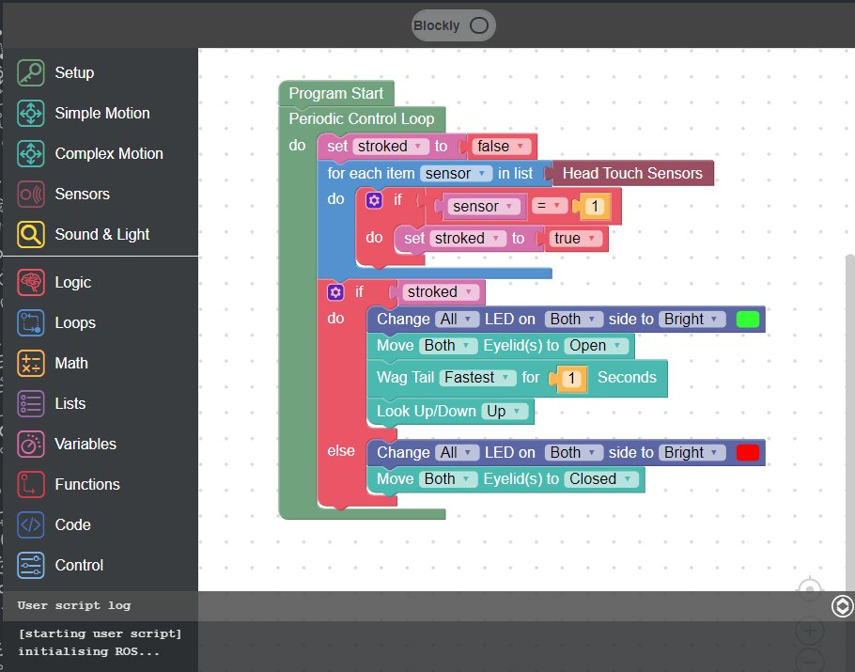  Script at bottom of screen shows code is ready to run. | 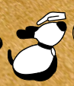  Simulate the stroking of the head by clicking this icon  OR  With physical MiRo - stroke MiRo’s head | 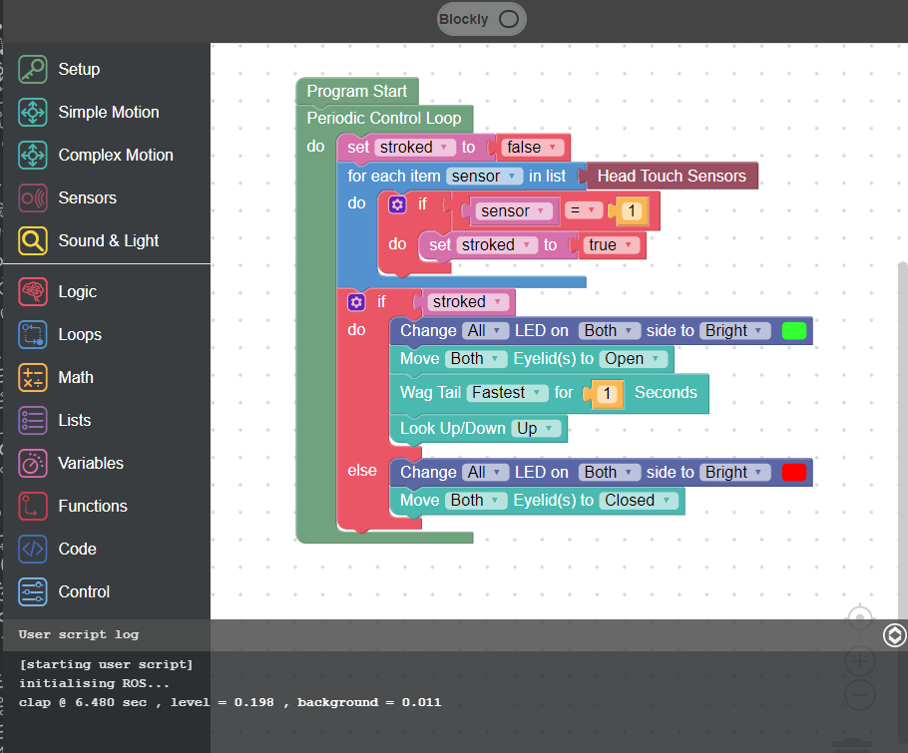  Script at bottom shows program ran correctly.
See the output |  | IF your hand touches MiRo’s head:  MiRo will open its eyes, wag its tail and  display green colours on its body  ELSE:  MiRo will close its eyes, and display red  colours on its body

